Residential students make significant progress with regards to their emotional wellbeing, educational achievement, self-esteem, confidence and independence skills. A parent who responded to a recent school survey said, ‘My son has grown from a timid insecure little boy to a young man who can confidently express opinions and has developed a true level of self-esteem.’ (Ofsted, 2015).
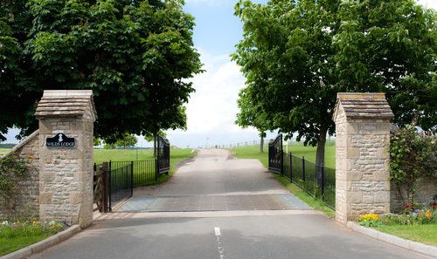
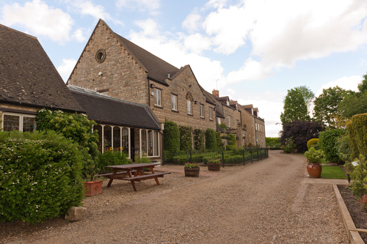
Wilds Lodge School is an independent boarding and day school for boys from 5 to 18 years with Social, Emotional, and Mental Health difficulties (SEMH). All 80 students have a Statement of Special Educational Needs (SEN) or an Educational Health Care plan (EHCP) and are placed by a wide range of authorities from across the country. The school was established in 2007 and has made significant progress in its provision since opening.

“The school provides a vibrant, motivational and nurturing environment to promote students’ educational and social development” (OFSTED March 2014).

Most of the boys at our school have had limited success in the classroom, sometimes from the very beginning of their school careers. They may lack confidence in their ability to make progress, and the learning environment can be perceived as threatening and are associated with failure and fear. Their relationships with their teachers have often been inconsistent and they may well have been blamed as the instigators of problems within the classroom.

“The exceptional premises and accommodation, which are continuously developed and improved, provide a marvellously rich environment in which students develop respect, independence and co-operation.” (OFSTED 2014)

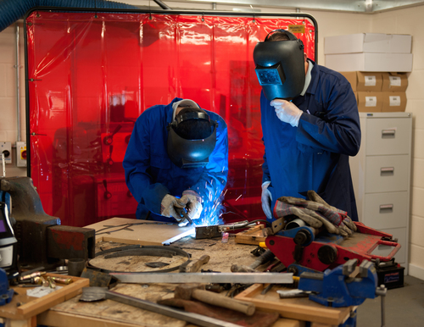
At Wilds Lodge, our aim is to turn these negative feelings into positive and optimistic views about themselves. We want our students to achieve as much as they can while with us, but almost as importantly, to be open and willing to continue learning when they eventually leave the school.

“The quality of the curriculum is outstanding” (OFSTED 2014)

“The leadership team has a strong commitment to improving practice and ensuring the quality of the service provided.” (March 2015)

The effectiveness of any school is ultimately dependent on the skills, attitude and capability of its staff team. Wilds Lodge has an unusually well qualified, enthusiastic and experienced staff team. Many have bought years of experience and a deep knowledge of the education of students with social, emotional, behavioural and mental health difficulties from working in other settings.

“Staff are highly qualified, caring, professional and extremely competent” (OFSTED March 2015)

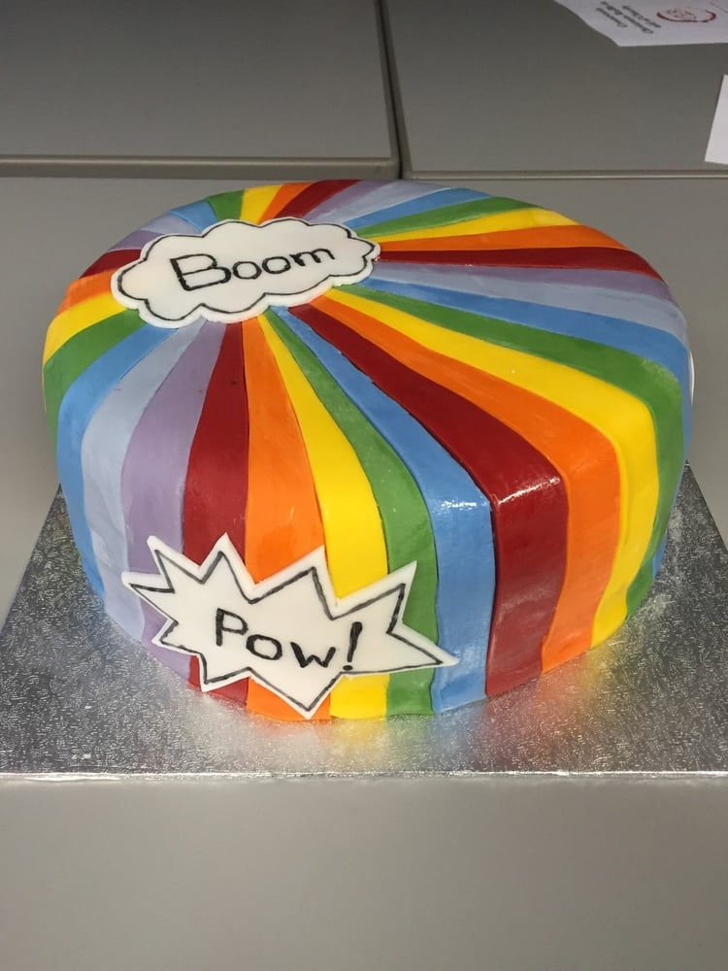
“All staff state that they feel well supported by the school through both formal and informal supervision”. (March 2015)

Our staff turnover is very low (7.4%, in the academic year 2014-2015). During that academic year, 8 staff left and 16 new staff were engaged. We had 108 staff in July 2015.
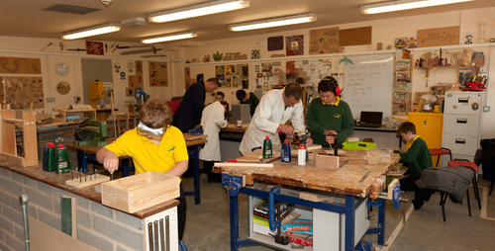
In 2014 we finished the construction of a large purpose-built classroom block to enhance our teaching facilities from September 2015. The pictures can be seen below. In addition to our existing classrooms we now have significantly larger classrooms for construction, craft, design and technology, art and a music/media centre. As a school we offer a wide range of academic and vocational qualifications as well as ASDAN and Duke of Edinburgh. We are fortunate to have been able to invest strongly in the school and have been able to develop a range of opportunities which are unrivalled by almost all other SEMH schools.

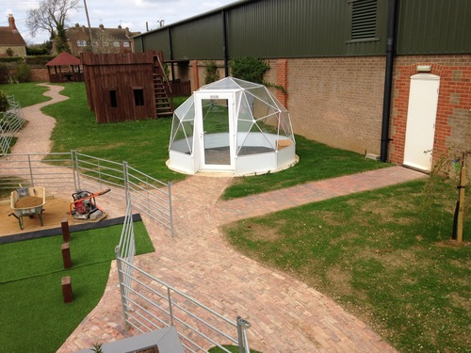
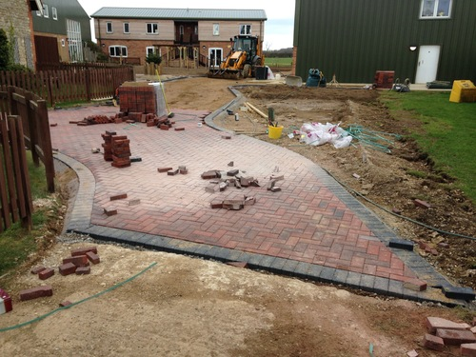
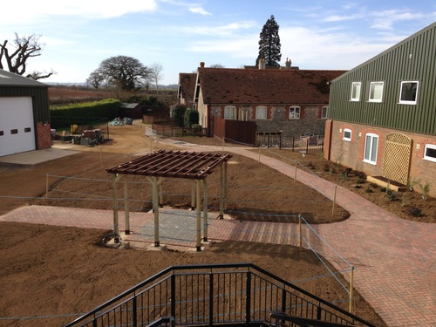
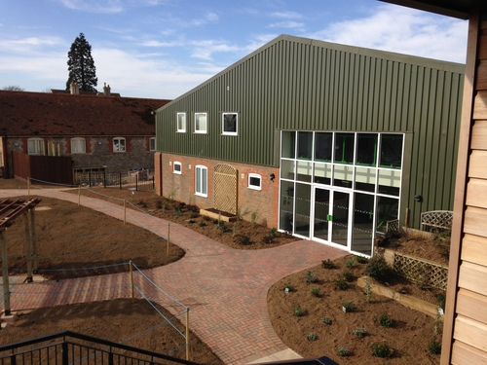

And the finished project.

As a staff team we have worked hard to engage the students in the school and allow them to feel that they have a voice and are able to have an influence in the school and the decisions that are made. This is an area in the past in which they have often felt very isolated from due to their previous experiences. We run ‘Student Voice’ which meets regularly to look at current issues highlighted by the students and also have been able to achieve the Eco-Schools Bronze and Silver Award since opening and in January 2016 achieved the Eco-Schools Green Flag award for the dedication of the school in their work towards sustainability. We have also achieved the ‘Values in Education’ award and in 2013 became an ‘Autism Accredited’ school and have also been working towards becoming a Forest School. We have been working towards the Educate and Celebrate certificate to become a LGBT+ friendly school. The achievement of the awards is the culmination of work that has been done by staff, parents and the students and it is important that this work is continued. For example, although the Autism Accreditation has been achieved there is on-going work to further our whole-school approach and an Autism Leader has been employed in this academic year (2014-15), rigorous whole-school staff training is underway in Autism Education Trust Level 1 and 2 and a fully immersive sensory room has been planned and installed over the summer for use in September 2016.

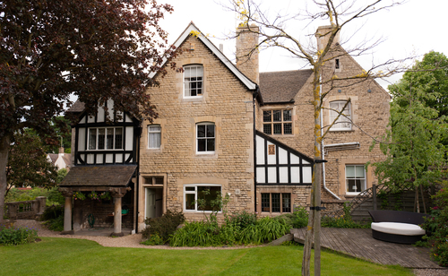
We offer counselling to students at our school and have a team of full time qualified psychotherapists and counsellors. All the staff in school work hard to establish strong relationships with the parents of our students. This academic year we have completed our work to refurbish a separate flat to enable our staff to work intensively with family members who may live at a distance from the school and need overnight or weekly stays. This therapeutic work with the family helps to strengthen relationships and work through complex issues.

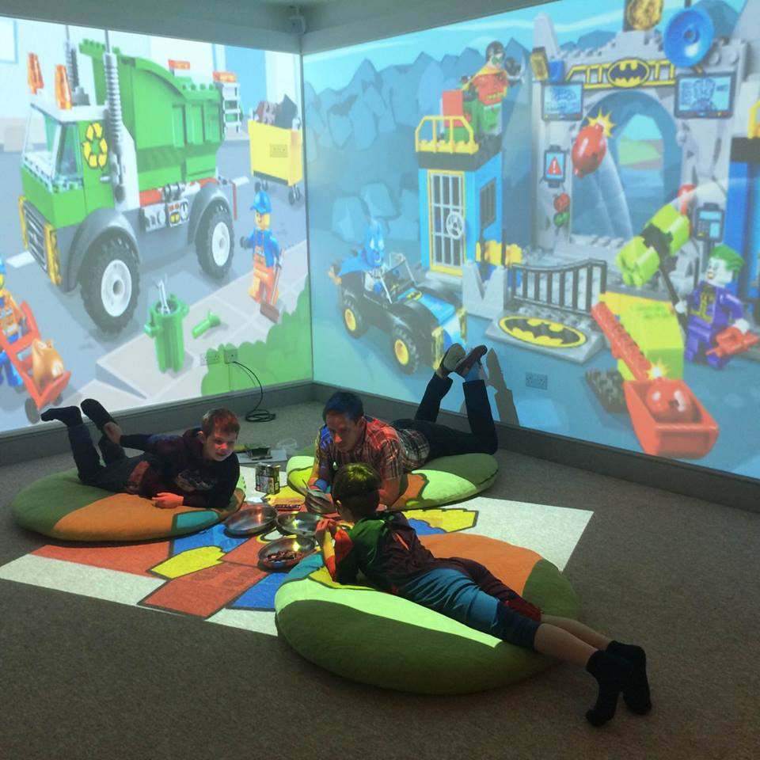
Sensory room.

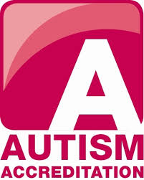
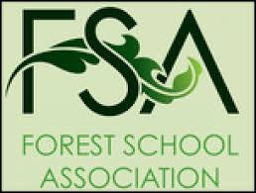

In the academic year 2014-2015 we have also begun work with the British Schools Council for their International Schools Award and UNICEF as a Rights Respecting School. These awards are all chosen very carefully as they fit the values and ethos of the school of rights and learning opportunities for all.

The students of Wilds Lodge often arrive having been excluded from mainstream education as they are unable to cope in a normal classroom environment. They have often spent a significant time out of education so have significant gaps and barriers to their learning. Despite this, in the academic year of 2014-2015 each of the 14 students left Wilds Lodge with some form of qualification ranging from Entry Level to GCSEs and BTECs. All of them had re-engaged with their learning and were able to move on to a Post-16 provision or college. The support that the school provides in helping this transition into mainstream college is carefully planned and has involved much collaborative work with local colleges and additional work experience placements to help our students build their confidence before they transition. Many of our students attend their chosen college at home for a day a week in their final year to help them gain familiarity with the setting before committing full-time. We have also been able to extend our work on independent living with our older students through the use of Rock Lodge, our new building located in Stamford and this has allowed the students to shop, cook and visit town independently but utilising the support of staff in preparation for their leaving.

Facebook is another area that we have been developing as a way to link with both parents and the local community. We have a very active Facebook page that is regularly updated and is a lovely way for family and friends to keep up with the wide range of activities that the boys take part in over the school week. This really does help them to build self-esteem and confidence and also give areas for discussion when they are at home. The site is also linked to our website www.wildslodgeschool.co.uk which has been re-developed recently.

Annual parental surveys are another way in which we can consider the work that we are doing and enables us to identify areas which we may need to reflect on and improve. The results of the surveys can be seen below and illustrate that overall parents are very happy with the school. The parents of the boys have often had very negative experiences of schools in the past as their child has struggled in their placements and a great deal of work is done with the parents and helping them begin to see schools in a positive light and as a collaborative work between the student, parent and school. This can be seen in their responses in the following graphs.
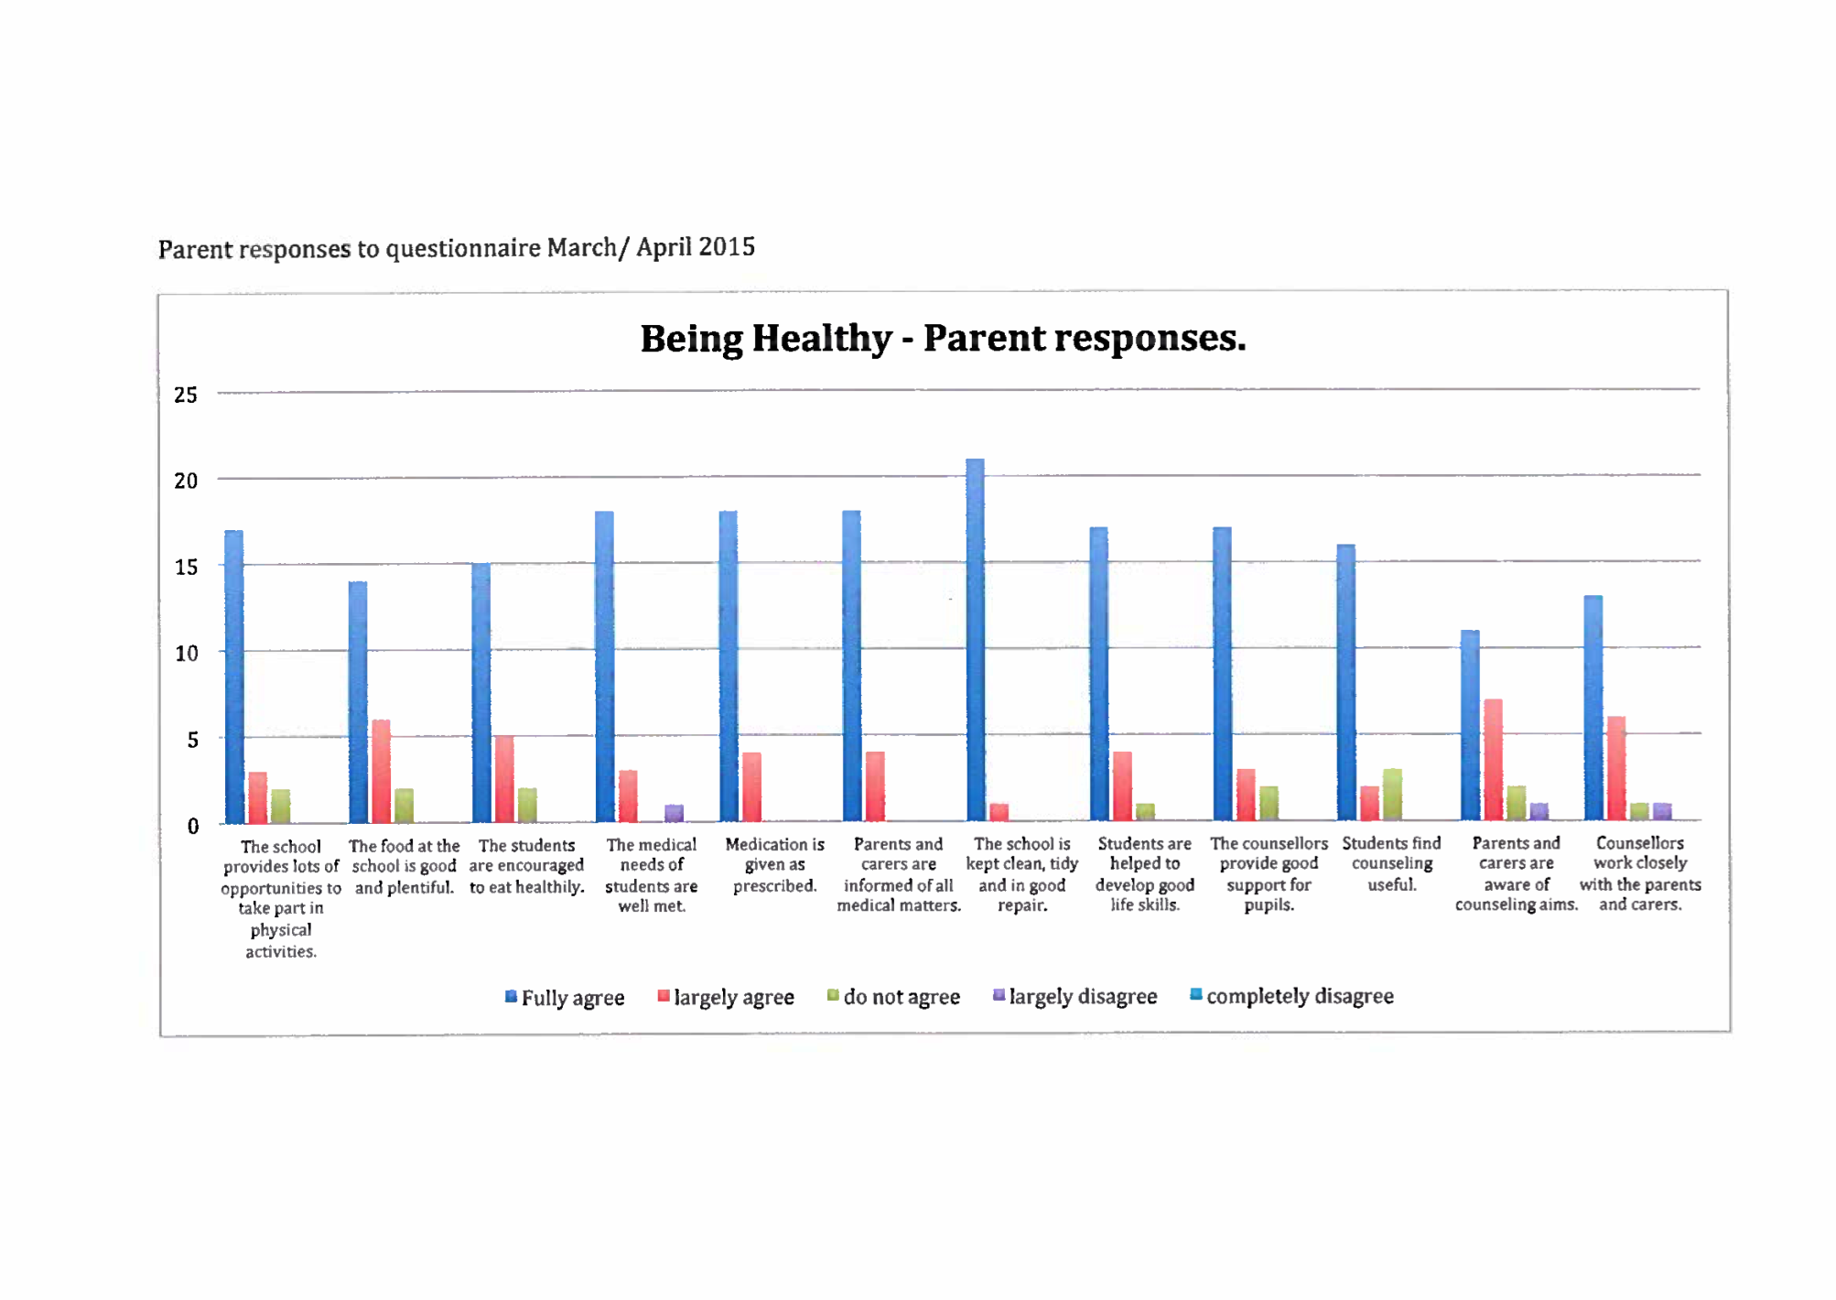

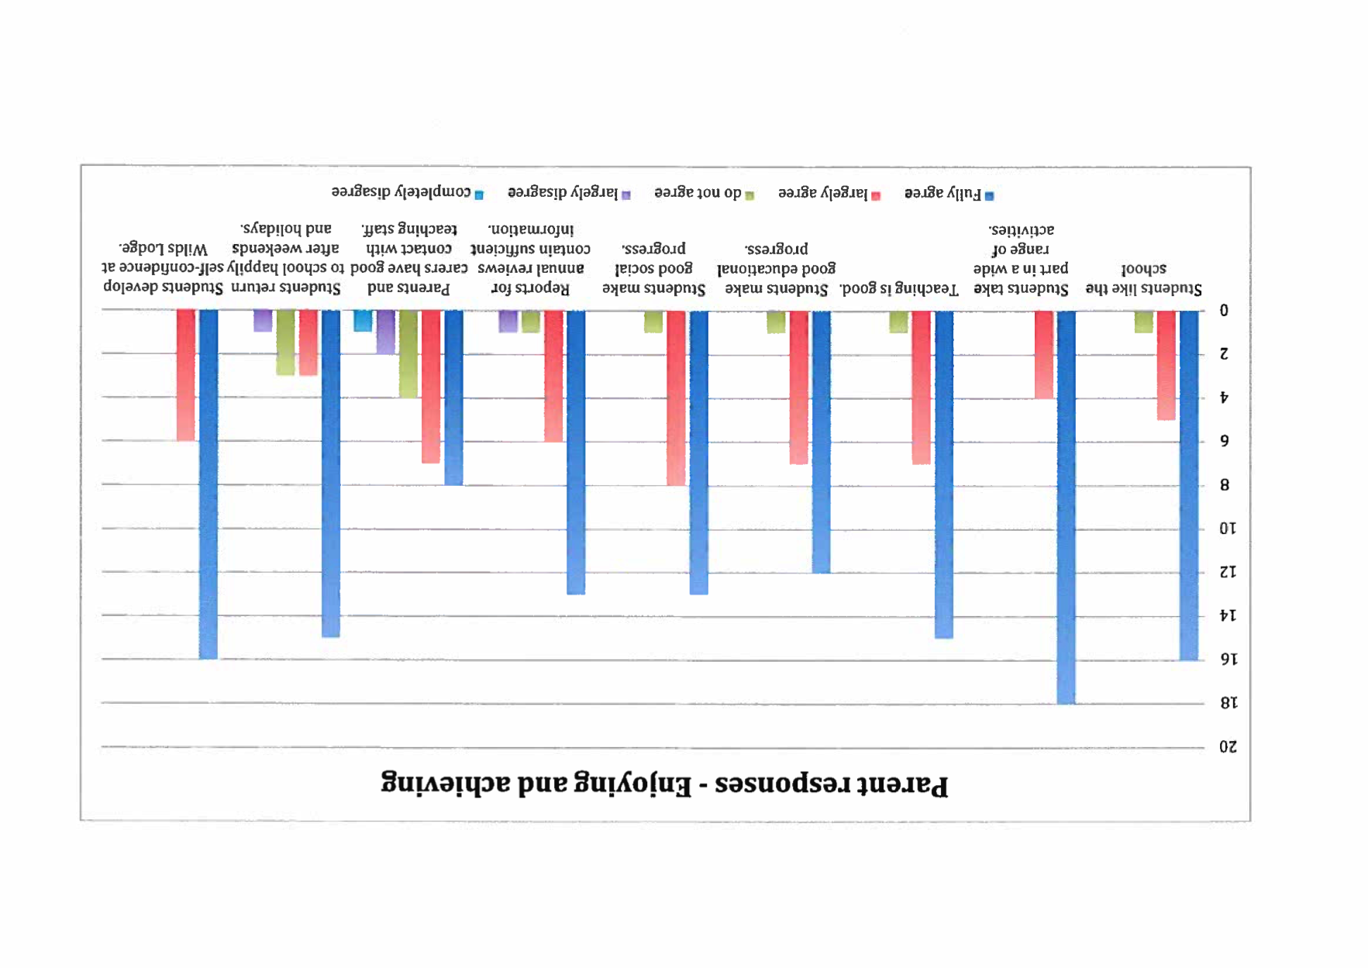

The academic year 2014-2015 was also when we decided to work with Elly Barnes on the ‘Educate and Celebrate’ programme which is a whole-school approach to challenge homophobic bullying and ingrained attitudes in schools. OfSTED has recognised this as best practice and highly successful in the work it does to make Lesbian, Gay, Bisexual and Transgender (LGBT) more inclusive in schools. We received training from Elly as a whole staff team and have been embedding the LGBT friendly resources and attitudes into our school throughout this academic year.

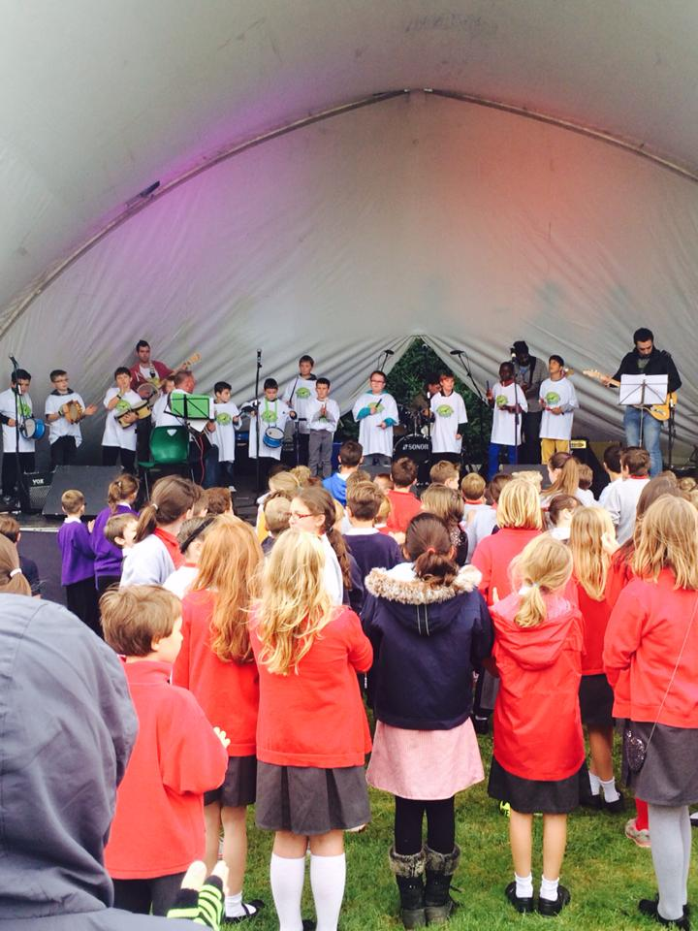
Wilds Lodge Music and Arts Festival has continued to grow since it began in 2011 and is a fantastic opportunity to link in with the local community and provide much needed opportunities for local children and our own students to perform in front of large numbers in both dance and music. OFSTED (2014) commented in our report graded as Outstanding that:
‘Arrangements for the spiritual, moral and social development of students are outstanding. There are wide-ranging opportunities for students to take part in activities within the local community. The school’s annual music festival, for example, involves musicians from local secondary schools and up to 300 Year 6 pupils from surrounding primary schools attend as an audience. Students take part in sporting events with other schools and visitors to the school contribute to students’ awareness of public services and facilities. Strong links have been established with local colleges and these are increasingly used to raise students’ aspirations to continue in education beyond school. Activities, for example through a citizenship day, provide students with an understanding of democratic processes and internal elections link effectively with the national voting system. There is a strong emphasis on tolerance and mutual respect throughout the life of the school, including trips to places of worship which provide opportunities to recognise the diversity of beliefs and cultures within the community’.

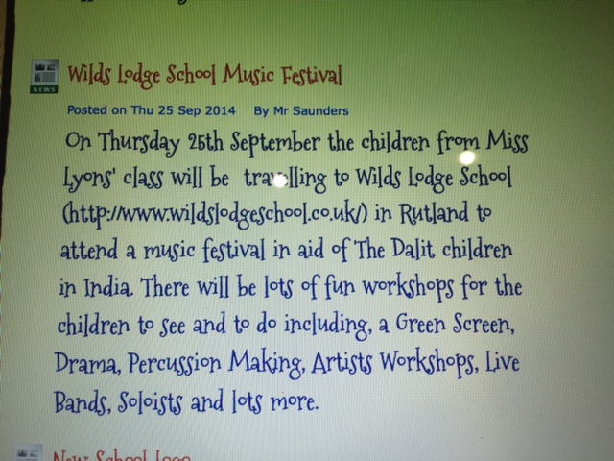
A screen shot from Fortuna School website.

Wilds Lodge is working with the Dalit project to fundraise to pay for a teacher to provide education for a year in one of the Dalit orphanages that we work with in Mumbai. The Festival gave us an opportunity to raise both awareness and funding for this important issue to other schools.

Higher Education Training and out-reach work.
Wilds Lodge has developed links with both Nottingham and Bishop Grosseteste University. As a school we are aware that within teacher training courses there are limited opportunities to work with and gain a knowledge and understanding of Special Educational Needs (SEN) and behaviour management. Many of the students that we have would have benefitted if there was a focus on these areas underpinning SEN into teacher training programmes as many have no understanding of some of the difficulties children with neglect, abuse, or recognised conditions such as Autism and ADHD can face. We also work with local schools in offering advice and guidance when they have challenging students. As a school we have worked with the universities to deliver lectures, specific workshops and we also offer placements for students on PGCE and Education Studies courses. As can be seen in the letters below from the Academic Coordinator and one of the students this has been a rewarding experience all round.

Dear Head Teacher:

I wanted to thank you personally for your support and encouragement of the second year Education Studies students who completed a placement with you recently. The students have come back to University exhausted, but inspired and ‘buzzing’ – full of talk of the things that they have been doing and the opportunities that you have provided. For most, this first ever ‘block’ placement has been crucial in that it has both consolidated and confirmed their career aspirations and provided them with a superb basis of professional knowledge that will stand them in good stead in upcoming PGCE/ School Direct applications. I also know that a small number of students were on a very steep learning curve and I have very much valued your guidance and encouragement of these individuals throughout the placement.

I genuinely appreciate your generosity in providing this opportunity for my students. I do hope that it was a positive experience for you.

I have attached three placement summaries, for Yr1, Yr2 and Yr3 students who will require placements in the next academic year, 15/16, and ask whether you would be willing and able to support these placements for us. I look forward to hearing from you in due course, or at your earliest convenience. We will however be contacting all schools in the latter part of the summer term.

Regards
Barbara Murphy Academic Coordinator, Education Studies

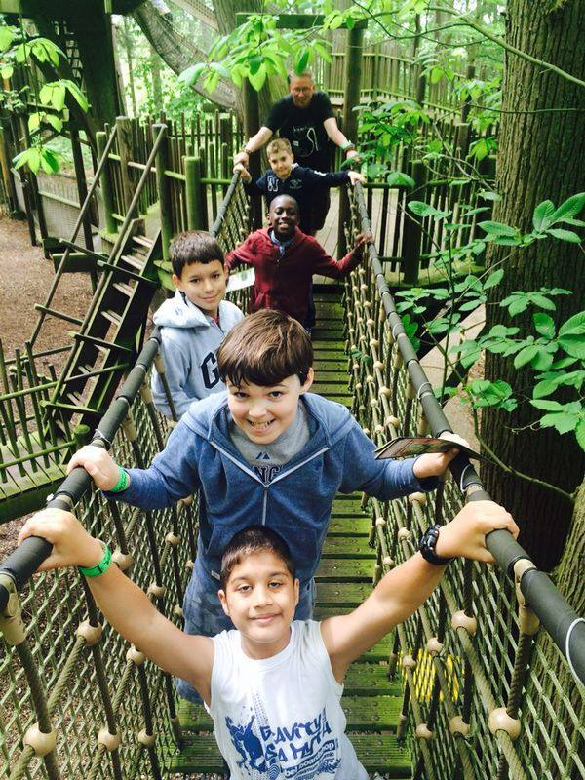
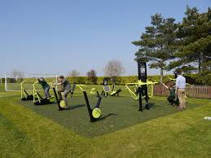
Wilds Lodge have a commitment to educating the students of the benefits that a healthy and active lifestyle can bring. In the academic year 2014-2015 we were able to plan and install (thank you school council) an outdoor gym to enable everyone to take part in activities of their choice at breaks, lunchtimes and after school. We also have termly inter-form competitions which all students are a part of in teams and these all add points up over the year culminating in our full day of sports activities on the last day of the summer term. All parents, family and friends are invited to the Sports Day and there are traditional sporting events, a picnic lunch, music and a closing awards ceremony.
Canal Environmental Project: An article from the school magazine.
Wilds Lodge school has been working in partnership with Oakham Angling Club to revive a canal section in Ashwell. Mr Mark Short the owner of HTL Fishing shop in Oakham approached the school asking for some help.

Mark said “The school was mentioned at our recent committee meeting and whether the boys could help our clubs volunteers in clearing and cleaning the canal to it’s former glory. About 7-years ago this section of the canal by the bridge in Ashwell was wonderful. It was an excellent place to fish with a wide variety other wild life. Unfortunately it has deteriorated and needs urgent attention.”
The school responded to the call for assistance and yesterday 4- boys and a member of staff went to the canal to join Mark and another club volunteer for an afternoon of clearing work. Two Metal dredges were attached on ropes to two fishing platforms and the boys were tasked to dredge and drag out weeds growing in the canal. This was important in promoting a clearer and cleaner canal bed to help oxygenate and encourage fish to feed. Brendan and Scott worked on one of the fishing platforms with Tommy and Charlie on the other.
Scott said “Throwing the metal dredge out and pulling loads of weeds in was hard but great fun”. Paul Rogers Teaching Assistant said “ It was fantastic to see the boys so enthusiastic and they have pulled out lots of weeds from the canal. I was delighted to see local dog walkers walking by and praising the boys for what they were doing. The other great benefit is that this work will be rewarded with an AQA certificate”
The project will continue for this summer term and every Tuesday afternoon boys will attend the canal to continue this important work. Next week one of the boys will be repairing and varnishing the wooden notice board at the footway entrance. He will also be tasked to hang wooden food stations for birds such as Kingfishers.

Mark said “The boys have done brilliantly today and have already made a difference with masses of weeds coming out. We plan to restock fish next October and are delighted that the school are involved in a worthwhile project.”

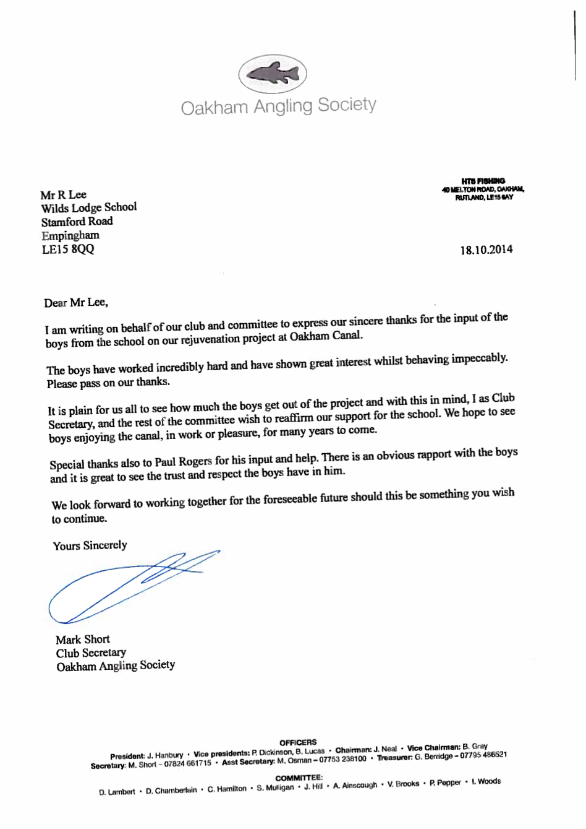

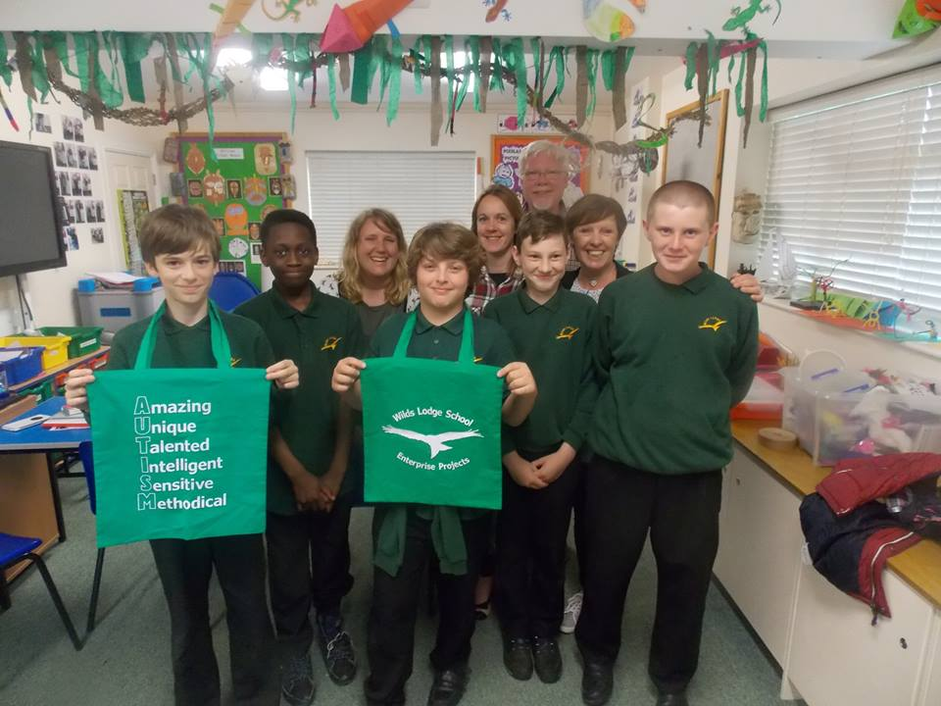
The enrichment of our students is one of our highest priorities and with this in mind we have designed a number of enterprise projects with the proceeds going towards the schools chosen charities. The purpose of these projects is to teach the students a range of skills which are transferable into everyday living as well as raising confidence and awareness of special needs such as autism. The most recent product they have developed is a bag for life designed specifically to raise awareness whilst also considering issues such as sustainability. The enterprise project was featured in our local newspaper helping to promote SEN in the local community.

Finally: Facebook reviews written directly by the parents in the review section (probably the most important view we can put forwards about our school).

‘After attending 5 other schools, finally my son has the understanding and nurturing he has craved for so long ! He is a changed boy for the better and I cannot praise this school enough for that ! I wish ALL schools were this good! Keep up the good work ! x’

‘Amazing place with amazing and caring people. My son has been here for a year now, and he has all the support he needs. The change in him is amazing all thanks to staff for all the hard work.’

‘An amazing place and my little lad has come along in leaps and bounds in the short time he's been there.
Thank you so much!!!’

